**DEPARTMENT PART**

**Estate Officer**

“**Application Receipt by Estate Officer cum Joint Secretary**”

**Step 1:**

Login as “**Estate Officer**” in Service plus web portal.

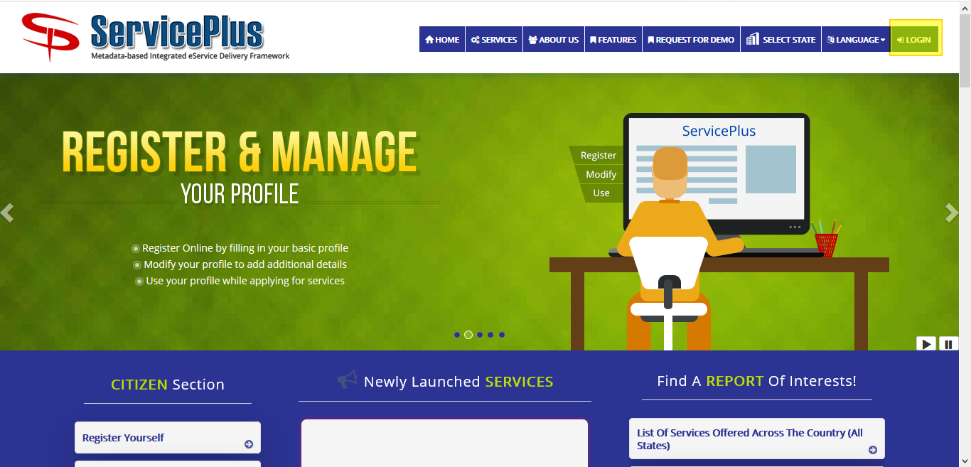

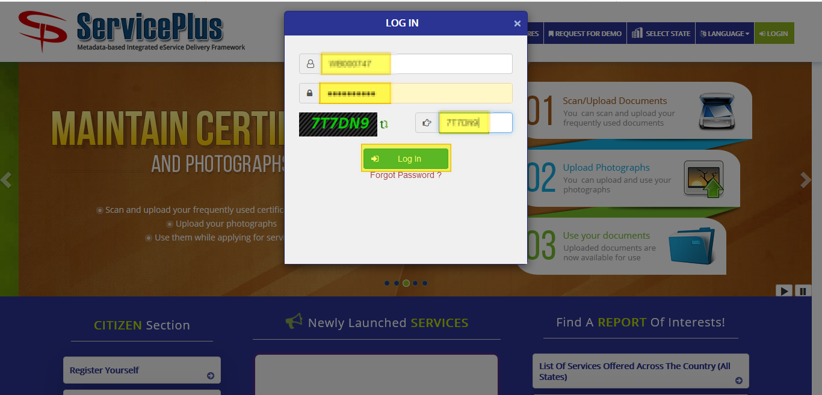

**Step 2:**

Now Go to **“Message Box”** and select **“Inbox”**.

In Inbox select the service **“Application for License Renewal of Flat in Bidhannagar Municipal Corporation Area”** and select the task **“Application Receipt by Estate Officer cum Joint Secretary”** and select **“Get Data”.**

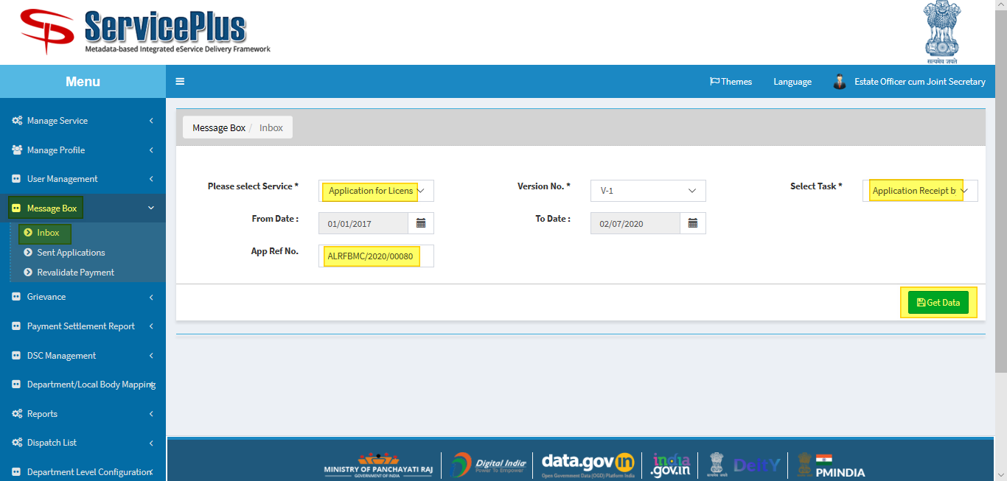

**Step 3:**

Select **“Pull”/ “Take Action”** to take action.

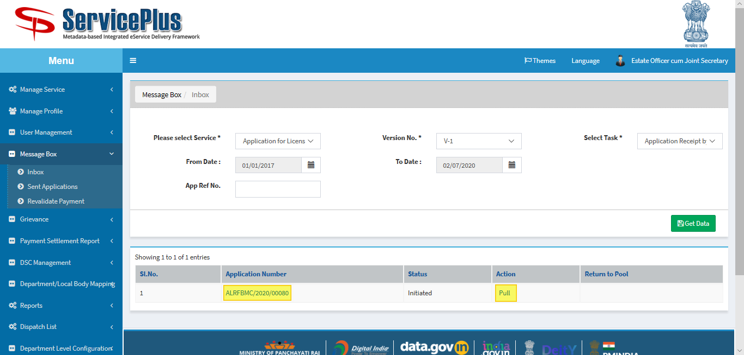

**Step 4:**

Select **“View Processing History”** to see the history of the application.

Action of the form can be taken by **Estate Officer** by taking action in two steps to **forward** and **Forward To-Supervisory Head Clerk** for Verification to “**Head Clerk”** and Give remarks and submit.

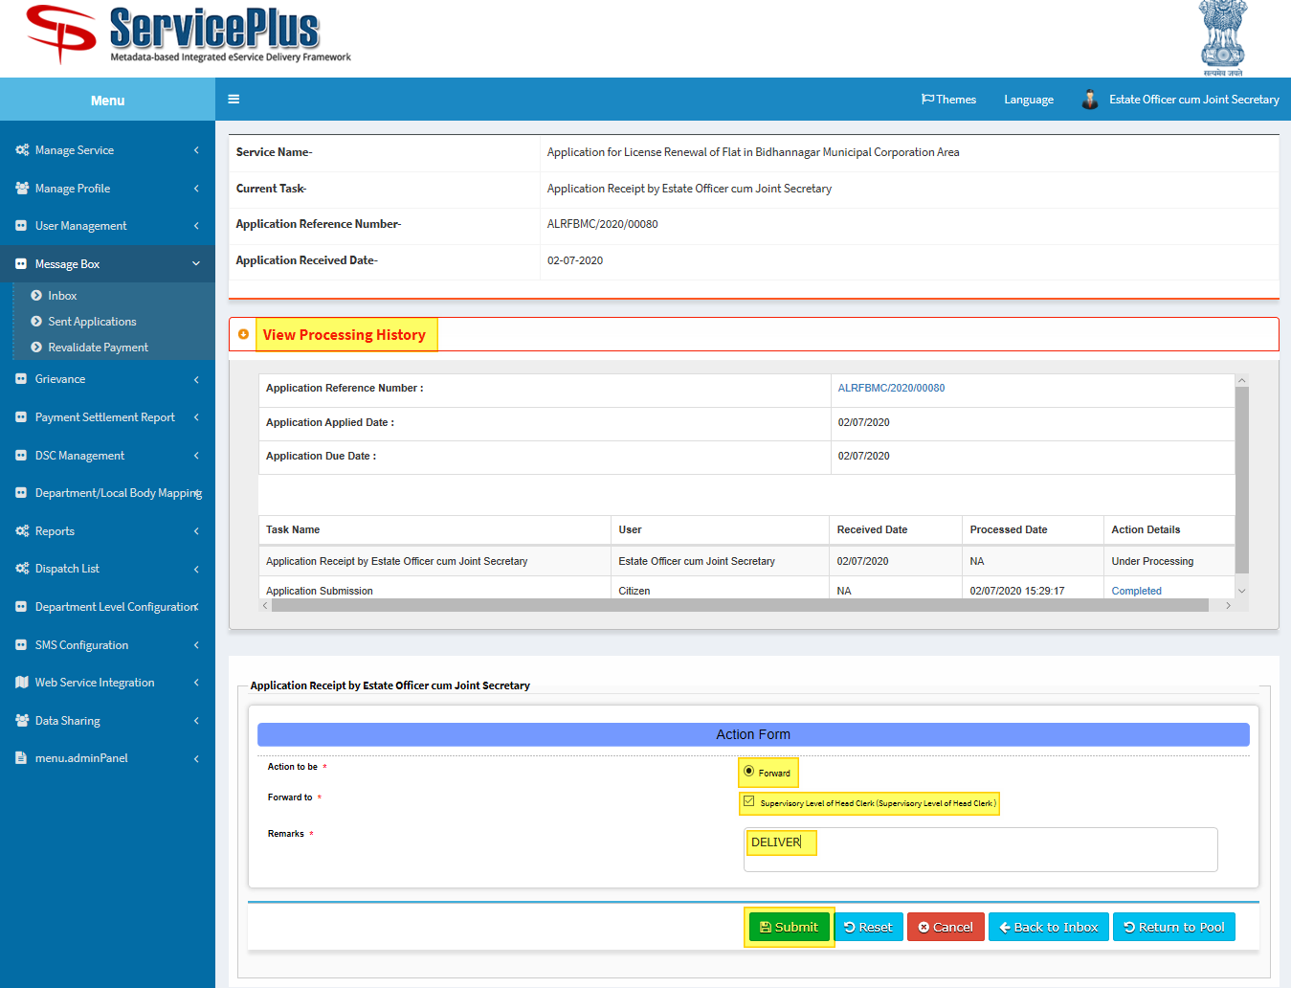

**Step 5:**

After Submit.

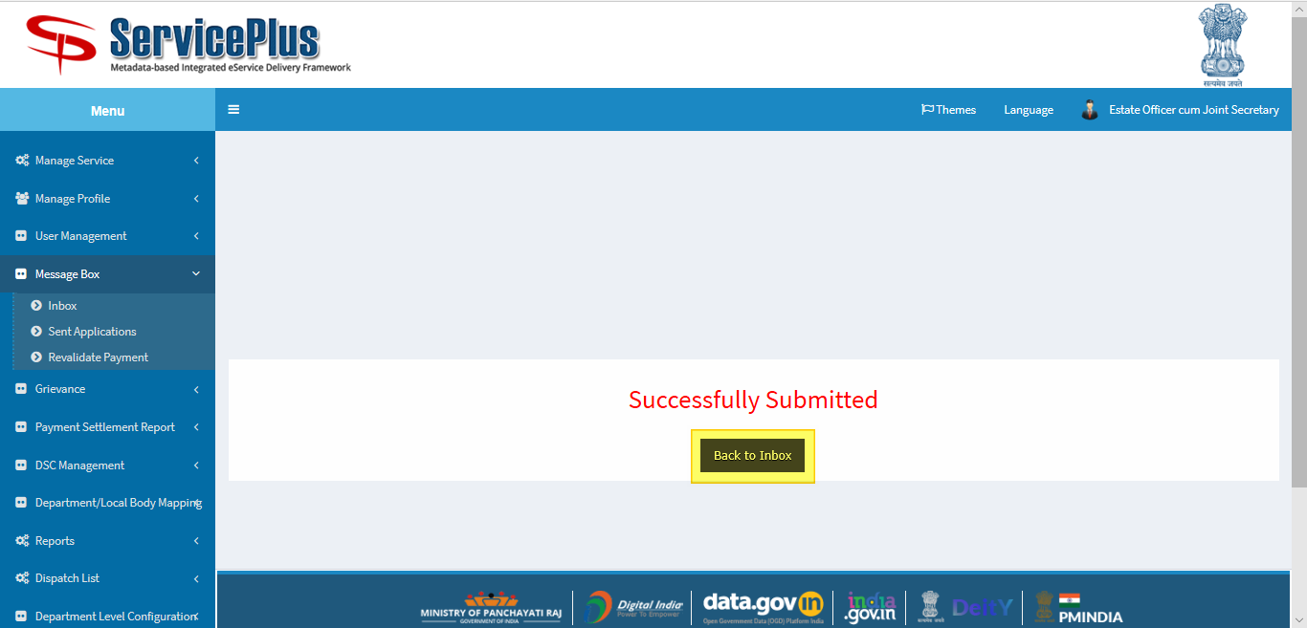

**Estate Officer**

**“Issuance of License by Estate officere cum Joint Secretary”**

**Step 6:**

Again Login as **“Estate Officer**” in Service plus web portal.





**Step 7:**

Select the service **“Application for License Renewal of Flat in Bidhannagar Municipal Corporation Area”** and select the task **“Issuance of License by Estate Officer”** and select **“Get Data”.**

Select **“Pull” / “Take Action”**.

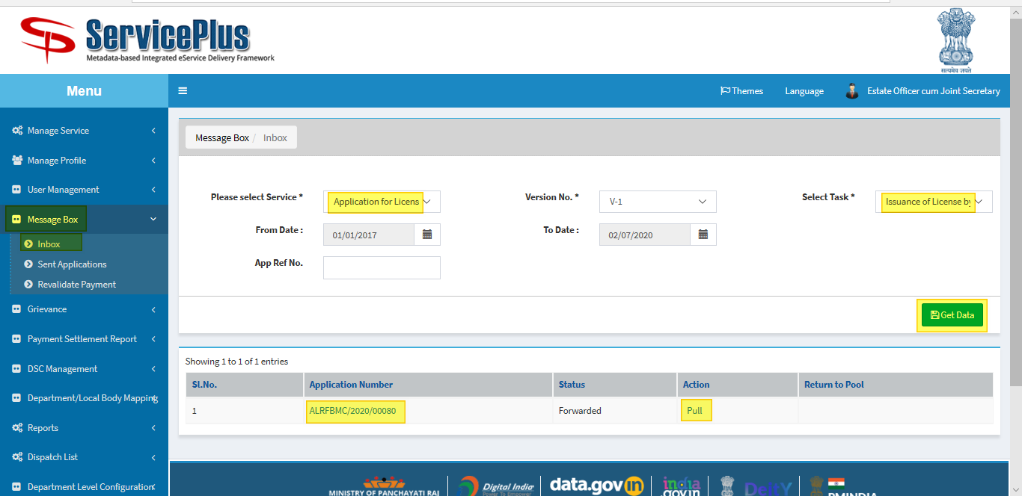

**Step 8:**

Select **“View Processing History”** to see the history of the application.

Action of the form can be taken by **Estate Officer** by taking action to **Deliver, Reject or Recommended**.

By selecting “**Deliver**”.

* **“Generate License for Govt Employee**” button is to hit to enable the submit button and **generate the license.**

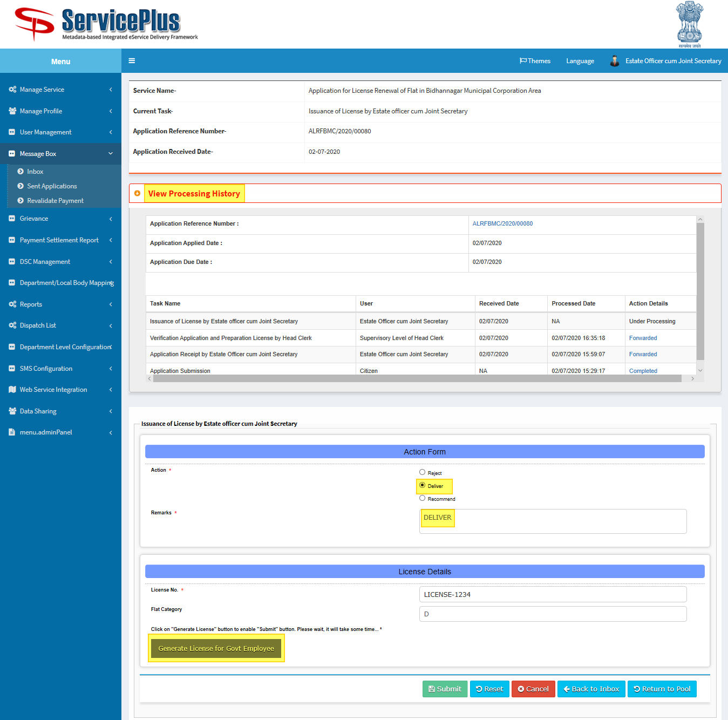

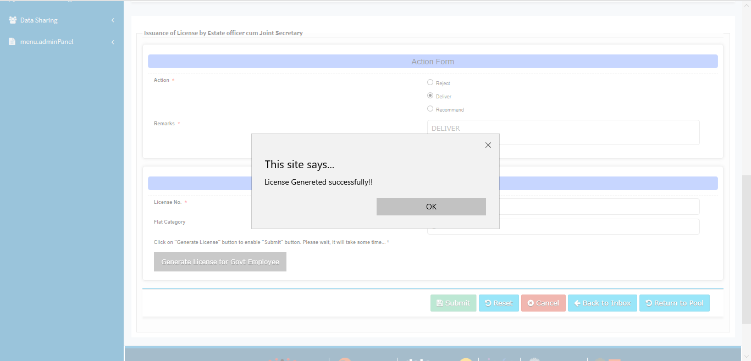

**Step 9:**

Submit button is enabled.

Submit it to deliver.

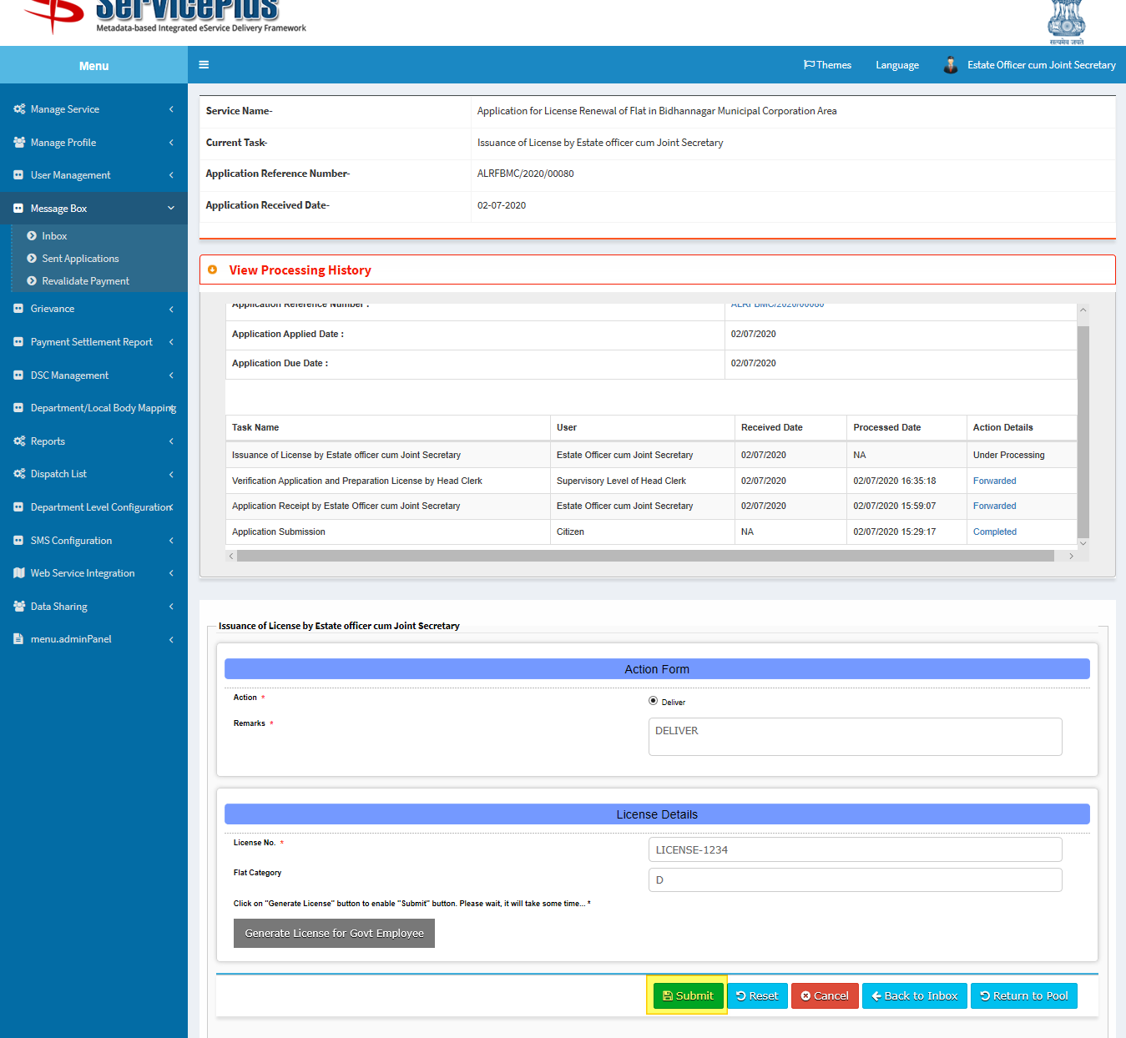

**Step 10:**

Here upload the file by clicking the **browse** button and **submit**.

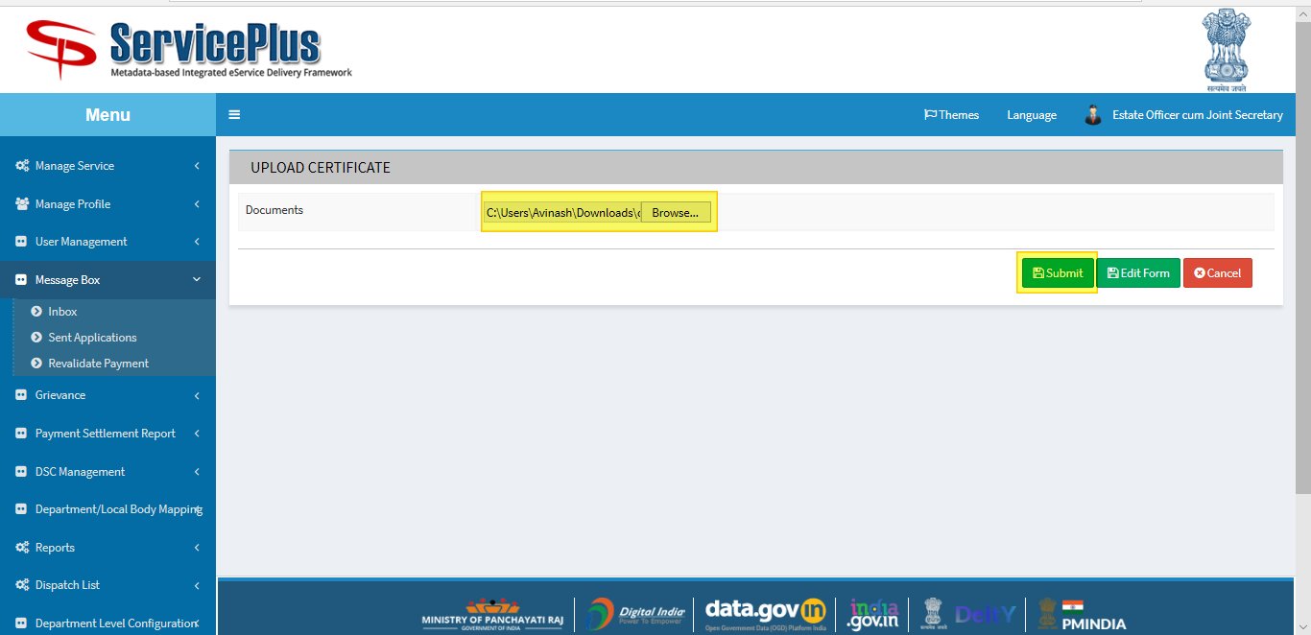

**Step 11:**

Here again download file by clicking the **file** icon and **submit**.

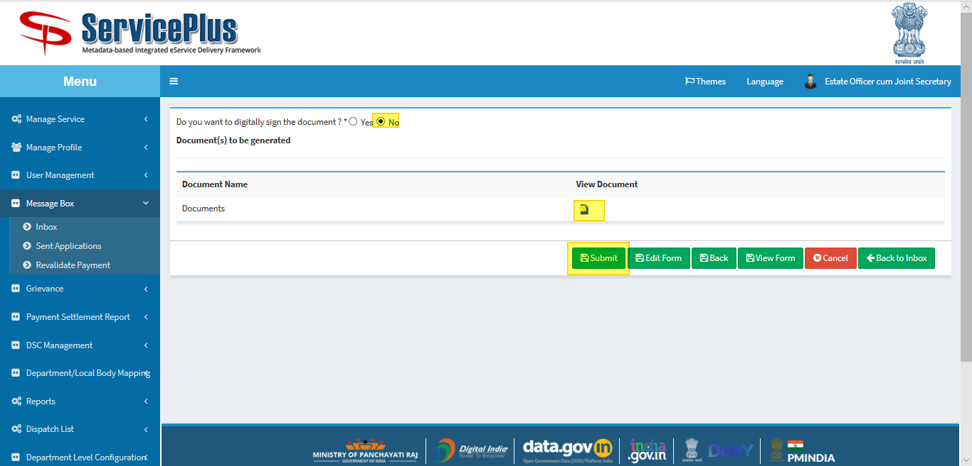

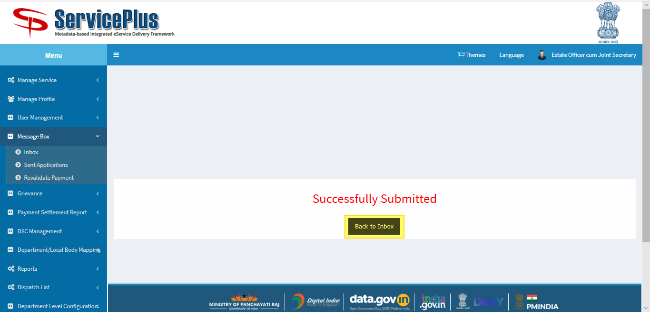

**SHORTFALL SELECTED**

**Estate Officer**

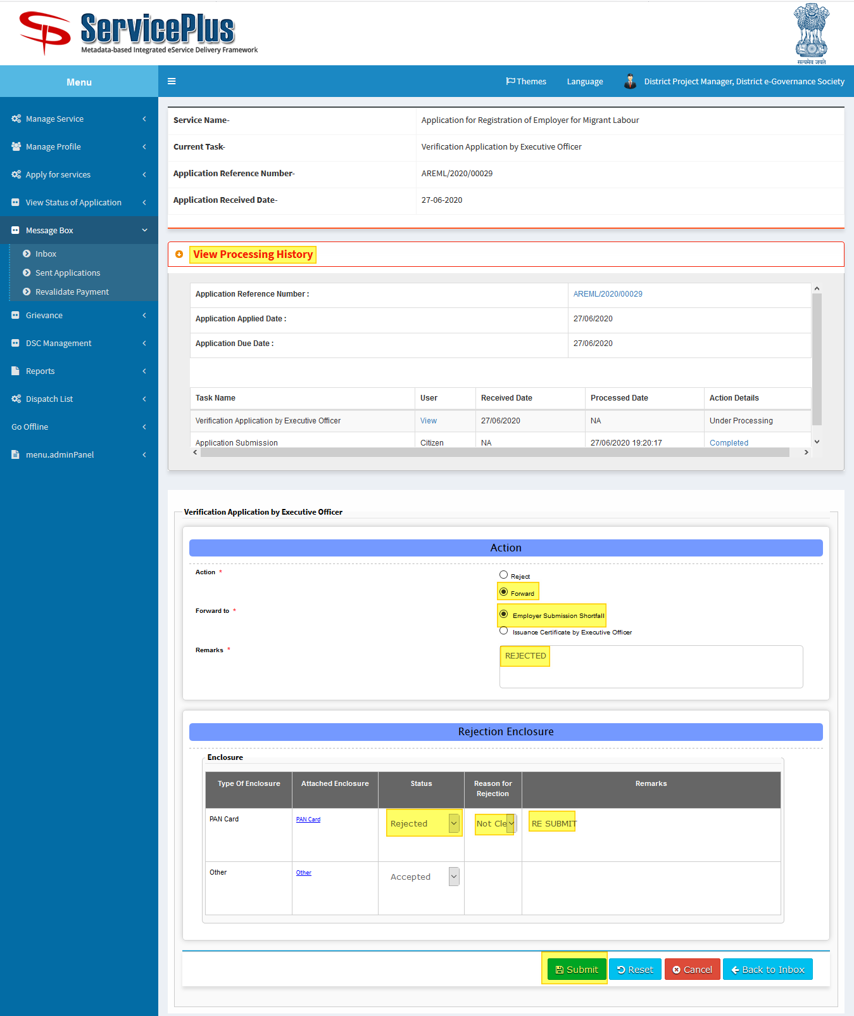

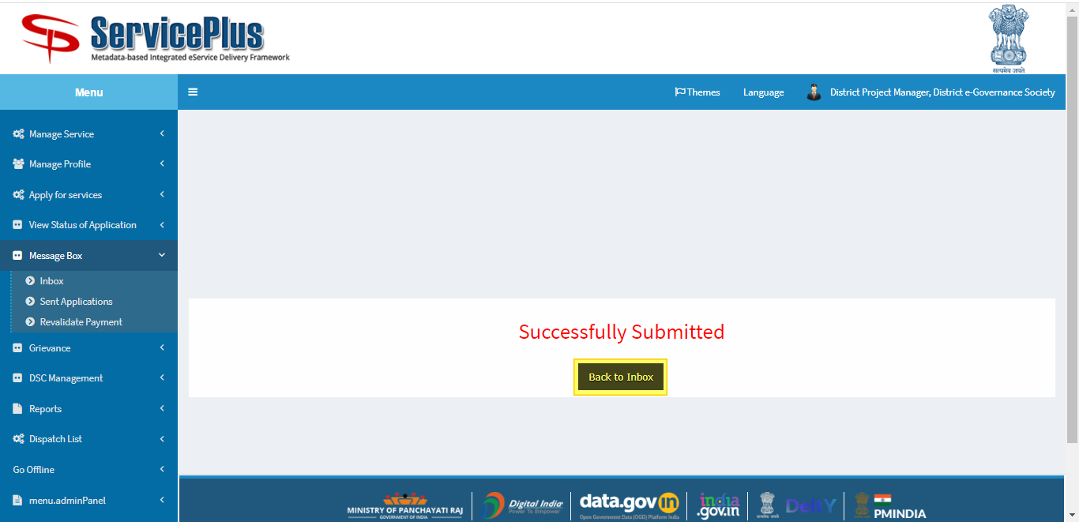

**RECOMMENDATION FOR REJECTION**

**Estate Officer**

**Step 1:**

Again Login as “**Estate Officer**” in Service plus web portal.



**Step 2:**

Now Go to **“Message Box”** and select **“Inbox”**.

In Inbox select the service **“Application for License Renewal of Flat in Bidhannagar Municipal Corporation Area”** and select the task **“Recommendation of Rejection”** and select **“Get Data”.**

Select **Pull/Take Action.**

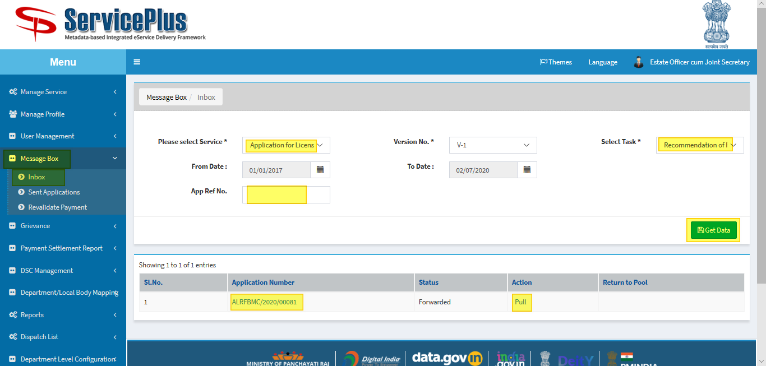

**Step 3:**

Select **“View Processing History”** to see the history of the application.

Here **Estate Officer** Takes action by selecting **Reject** and giving **remarks** and submit.

